1. INTRODUCTION
   1. Overview

Creating certificate for the event

* 1. Purpose

To engurage the participants

1. Problem definition & design thinking

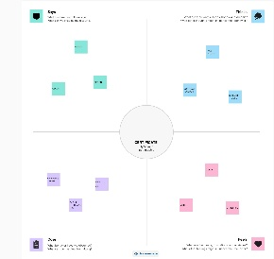 2.1 empathy map

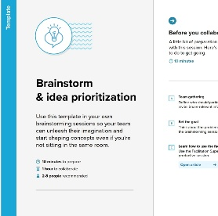 2.2 ideation & brainstorming map

1. Result

By using the templates in CANVA we have created the certificate design

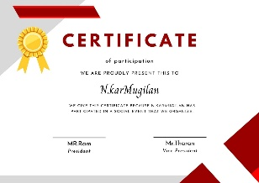 design

1. Advantages

We can use this fixed design for various events by changing the content alone .

1. Disadvantages

Some templates are in paid option

1. Conclusion

With the help of Canva app we created this certificate design easily